DATA-236 Sec 21 & 71 - Distributed Systems for Data Engineering HOMEWORK 2

Vimalanandhan Sivanandham 017596436

GitHub link for full code artifacts -

# Instructions:

* Please provide the screenshots of code solution for each question along with its intended output. Ensure that the code and corresponding output screenshots are placed together, one below the other.
* Submission should be in PDF Format.
* Please name your submission file as {last_name}_HW2.pdf

**Part 1. HTML & CSS (4 points) - Artist Liberty.**

**Part 2. HTTP, Express, NodeJS (6 points)**

1. Write the code to add a new book. The user should be able to enter the Book Title and

Author Name. Once the user submits the required data, the book should be added, and the

user should be redirected to the home view showing the updated list of books. (2 points)

1.Write the code to add a new book. The user should be able to enter the Book Title and Author Name. Once the user submits the required data, the book should be added and the user should be redirected to the home view showing the updated list of books. (2 points)

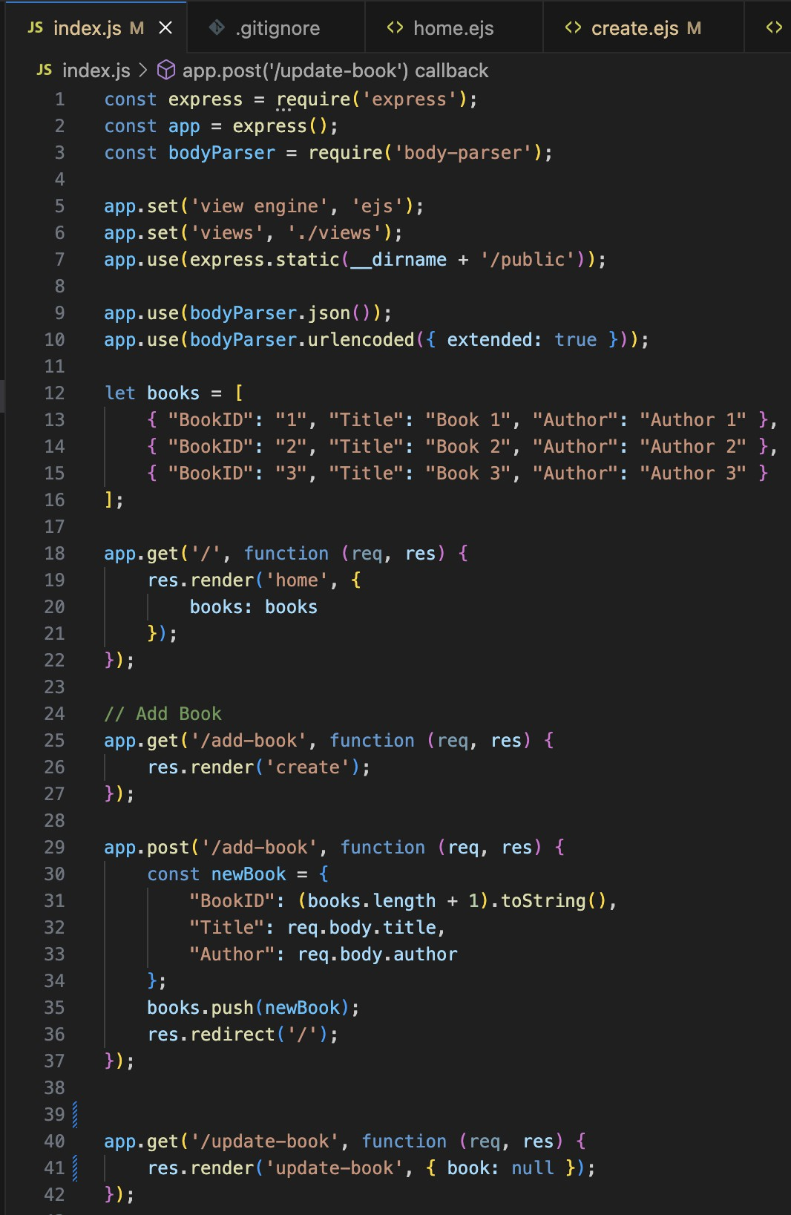

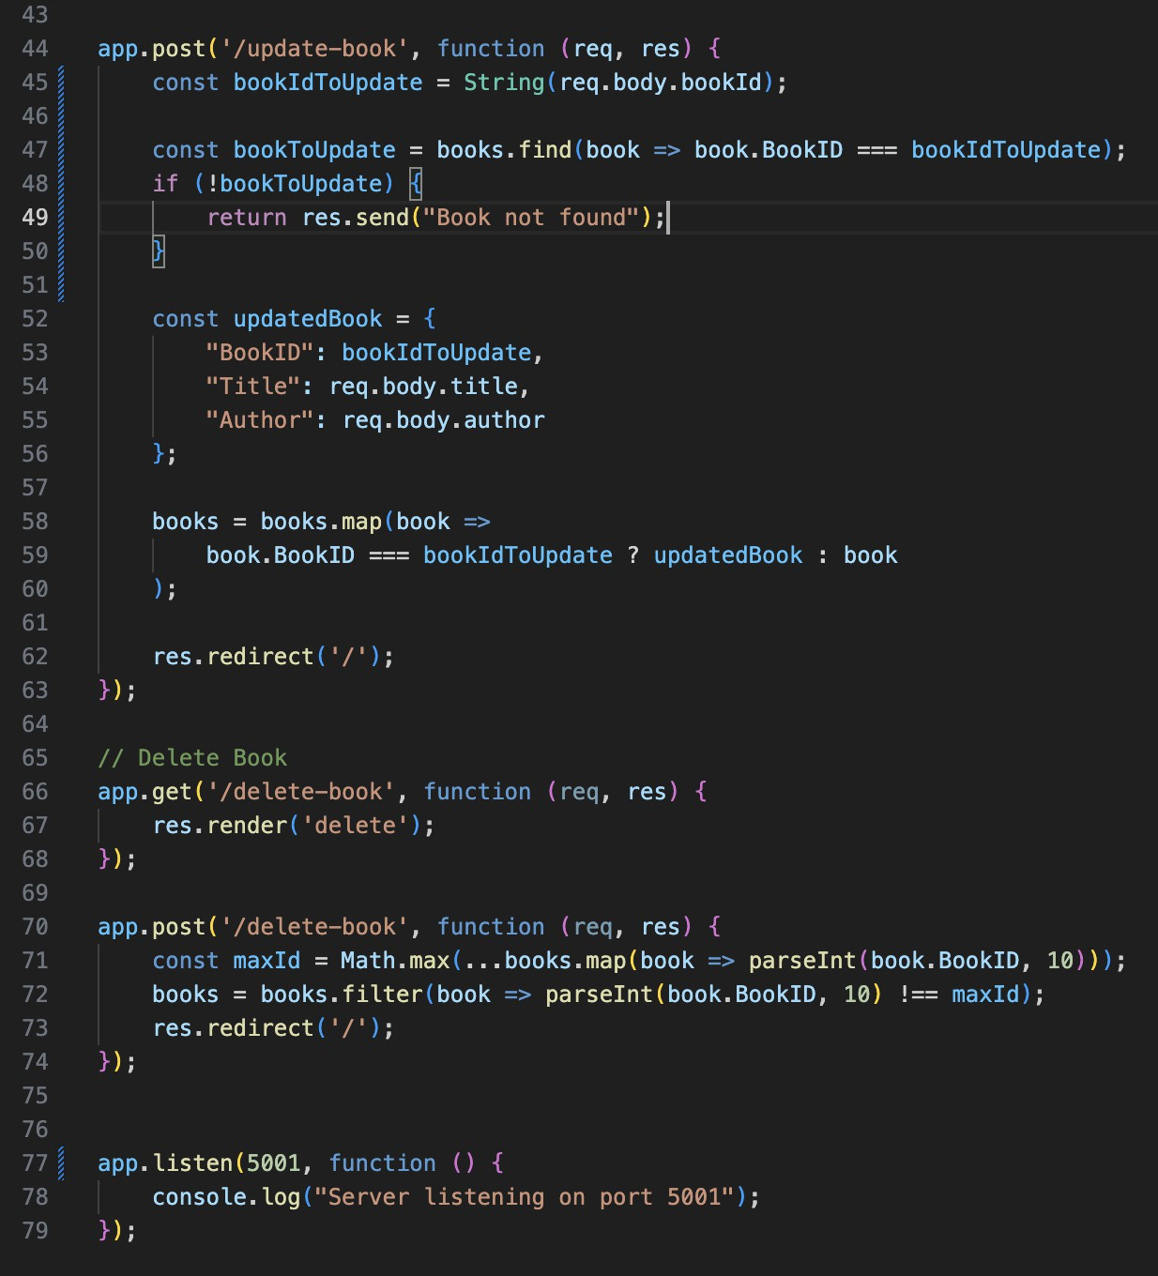

2.Write the code to update book with id 1 to title:”Harry Potter”, Author Name: “J.K Rowling”. After submitting the data, redirect to the home view and show the updated data in the list of books. (2 points)

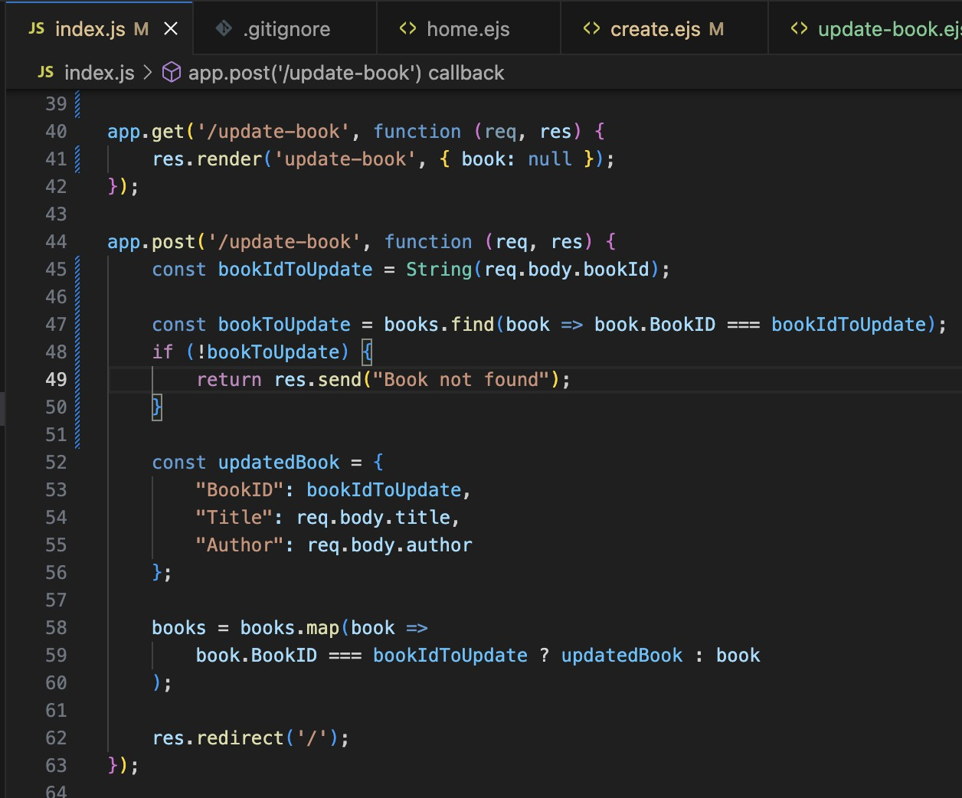

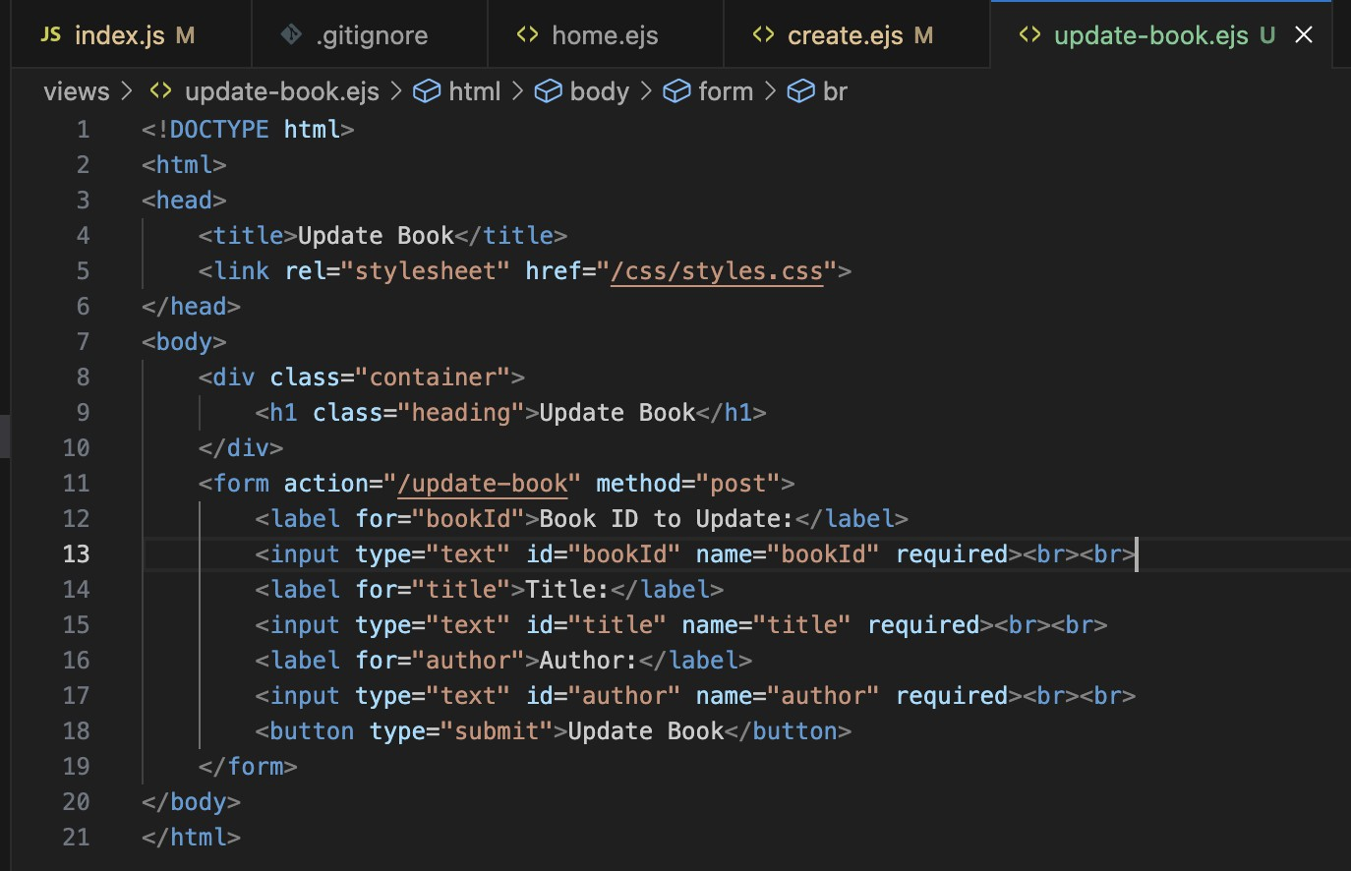

3.Write the code to delete the book with the highest id. After submitting the data, redirect to the home view and show the updated data in the list of books. (2 points)



